<https://app.diagrams.net/#G1MLZJ73EGmnnE3dKkMgP0tZhaFiFskJ0X>

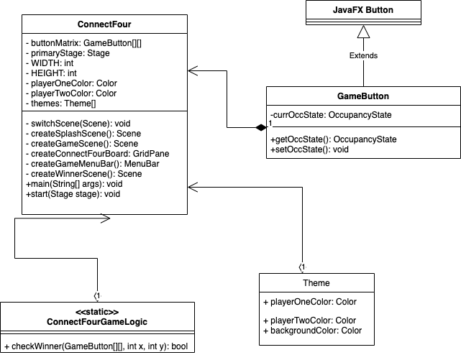

Theme colors:

1. <https://colorhunt.co/palette/f6d7a7f6eabec8e3d487aaaa>
   1. 
2. <https://colorhunt.co/palette/f5c6a5ff7777a2416b852747>
   1. 
3. <https://colorhunt.co/palette/c6d57ed57e7ea2cdcdffe1af>
   1. 

Notes for color transition: <https://stackoverflow.com/questions/40897365/background-color-transition-on-a-javafx-8-node-region-pane>

Add edge case if there are no more spaces left to fill

|  |  |  |  |  |  |  |
| --- | --- | --- | --- | --- | --- | --- |
|  |  |  |  |  |  |  |
|  |  |  |  |  |  |  |
|  |  |  |  |  |  |  |
|  |  |  |  |  |  |  |
|  |  |  |  |  |  |  |

Neel (nparikh2):

* Designed and animated splash scene
* Updated splash scene design
* Designed and linked end scene to main game
* Constructed logic for game winner sequence.

Von (vcayas2):

* Built scenes skeleton
* Created gameboard
  + Added button logic placement
* Created themes
* Created menu bar
* Created reverse menu and move history
* Added testing for game logic.